**BASE BUILDING ASSIGNMENT**

ASSIGNMENT QUESTION

Q1:- What are inline and block elements in HTML and difference between them? Name a few inline elements and block elements?

### ANS:- *Inline Elements:*

* ***A line break is not used to begin an inline element.***
* ***It uses the space that is required.***
* ***An inline element will not start on a new line and only take up as much width as necessary.***
* ***Some examples of the inline element are-***

***<a> <abbr> <input> etc***

***Block Elements:***

* ***A block-level element always begins on a new line and browsers add a space before and after the element.***
* ***A block-level element always occupies the entire available width of the webpage i.e it stretches out to the left and right as far as possible.***
* ***<p> <div> are commonly used block elements and will start in a new line and take up the full width available.***
* ***Some other examples of block-level elements are:***

***<h1>-<h6> <form> <video> <fieldset> etc***

Q2:- How to work images in HTML and explain in detail </img> tag important attributes?

## ANS:- **Definition and Usage**

***The****<img>****tag is used to embed an image in an HTML page.***

***Images are not technically inserted into a web page; images are linked to web pages. The****<img>****tag creates a holding space for the referenced image.***

***The****<img>****tag has two required attributes****:*

* ***src - Specifies the path to the image***
* ***alt - Specifies an alternate text for the image, if the image for some reason cannot be displayed***

**Note:**  **flicker while the Also, always specify the width and height of an image. If width and height are not specified, the page might image loads.**

**EXAMPLE:-** <img src="img_girl.jpg" alt="Girl in a jacket" width="500" height="600">

Q3:-HOW to create lists in HTML?

# ANS:- 1- Ordered List

**Ordered list is the list ,which shows the number or the position of the item and every item starts with**

• **tag and ends with**

**Like the below example:**

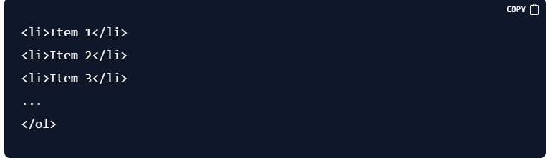 **result:**

1. **Item 1**
2. **Item 2**
3. **Item 3**

# 2- Unordered List

**An unordered list is a list in which the position of that item isn't shown. Instead of a number, there is a rounded circle. Looks like this :-**

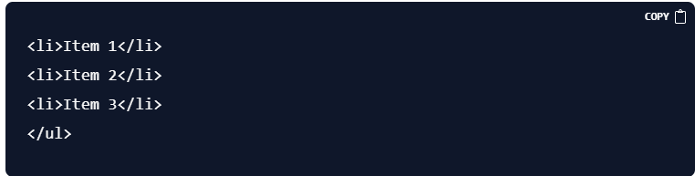 **result:**

* **Item 1**
* **Item 2**
* **Item 3**

# 3- Description List

**A description list is a list of terms, with a description of each term. a**

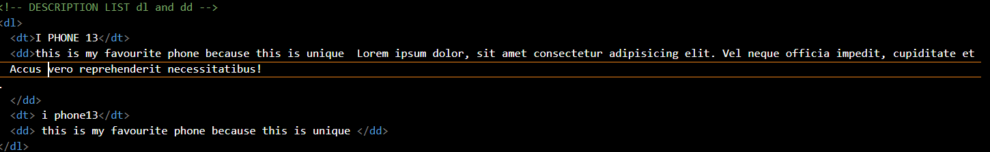**tag defines description list and a tag defines description term. Looks like this:**

**RESULT:-**

**I PHONE 13**

**this is my favourite phone because this is unique Lorem ipsum dolor, sit amet consectetur adipisicing elit. Vel neque officia impedit, cupiditate et sunt non. Dolor dolores incidunt officiis? Error quae accusamus odio iure accusantium nesciunt porro repudiandae minima! Accus vero reprehenderit necessitatibus! .**

**i phone13**

**this is my favourite phone because this is unique**

Q4:- How to interlink web pages and navigate people to other websites ?

* ANS:- The tag used for interlinking is the anchor tag or <a> element.
* Links also called hyperlinks are used in websites to allow users to navigate from one web page to the other.
* When a user clicks on a link, they are taken to the description page specified by the link.
* Syntax:

<a href=””></a>, where href is called reference or hyperlink

E.g.

<a href=”hhtp://[www.google.com/”](http://www.google.com/%E2%80%9D)\> Google </a>. So, Google will be displayed on the webpage and when the user clicks on google user will be redirected to the address that is given as a reference or hyperlink.

* To open a link in a new tab, the target attribute is used

E.g.

<a href=”http://[www.google.com/”](http://www.google.com/%E2%80%9D) target= “_blank”> Google </a>

* Attributes that can be used are- target, download, title